**Tata Center for Technology and Design Admin Panel & User Website**

Introduction

In Current scenario, admin team from Tata center updating their website manually. It is tedious job to maintain website for changes or updating website. They require admin panel through which staff can able to add/edit/ delete content from website. Information added or updated in website will reflect on Tata Center for Technology and Design portal,

<http://www.tatacentre.iitb.ac.in/>

Functionality

By admin panel staff can,

* Add new project, update existing project, delete project content as well as add/update multiple projects at a time by uploading excel file.
* Add new / edit / delete people (Executive Committee, Principal Investigator, Associate Faculty, Visiting Faculty, Project Fellows, Alumni, Staff)
* Managing Project related activities
* Managing Facilities, Career, Courses content.

Project Domains

There are total 7 project domains as below

1. Agriculture and Food
2. Water
3. Energy
4. Healthcare
5. Education
6. Housing
7. Waste Management

Each domain having multiple projects and people who are working on it.

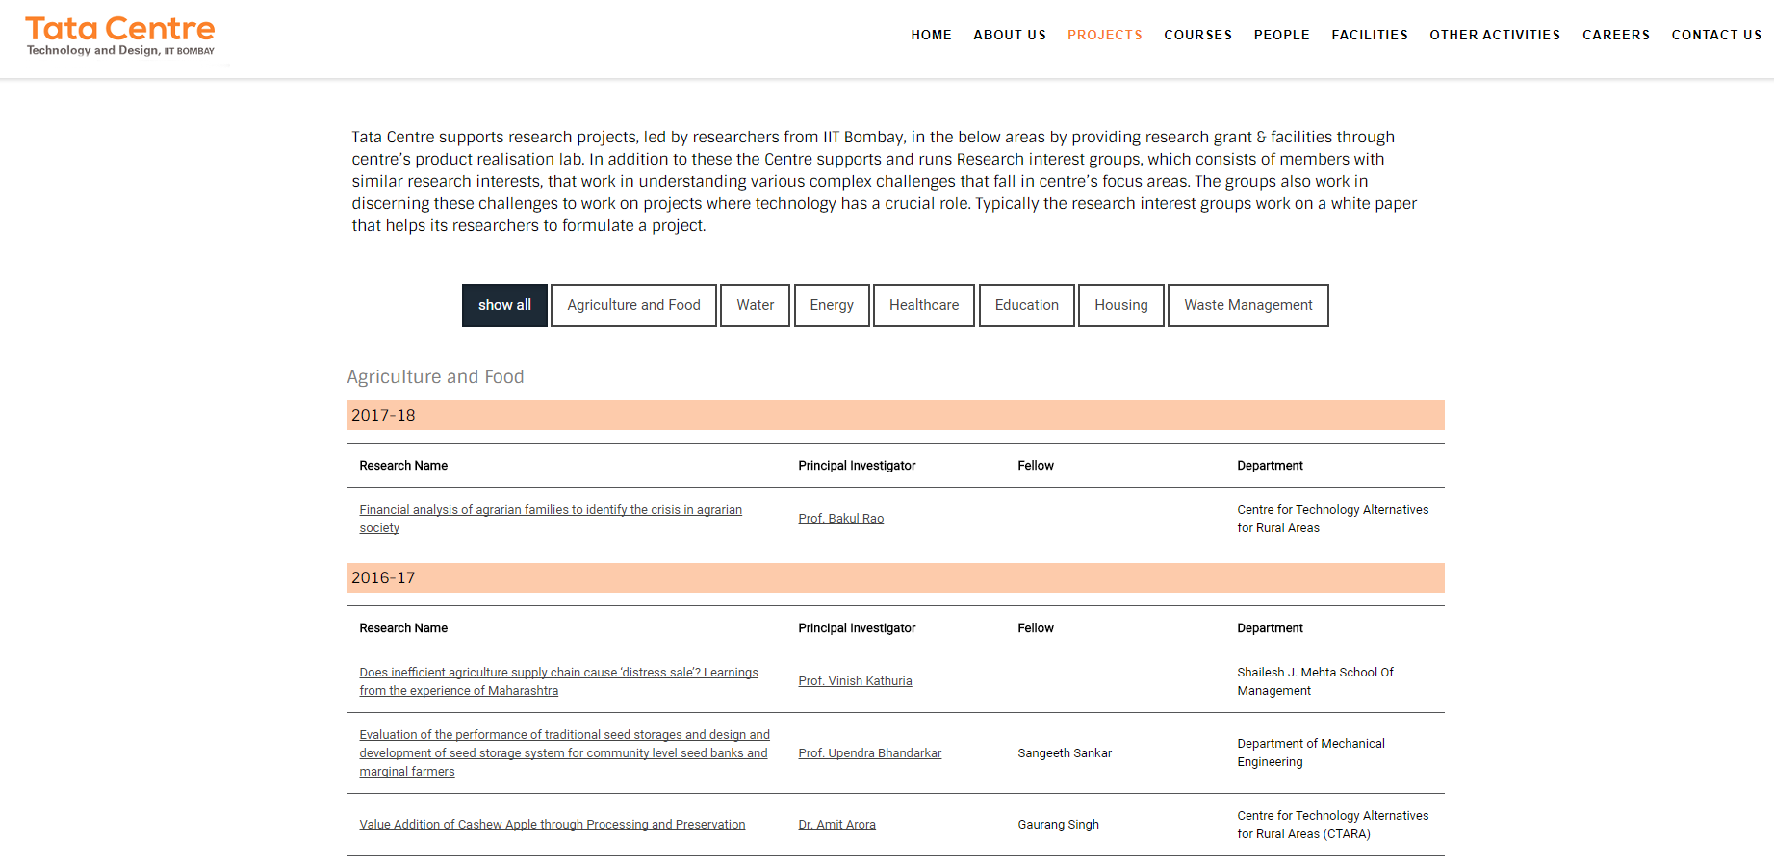

Current Project Page (Fig 1)

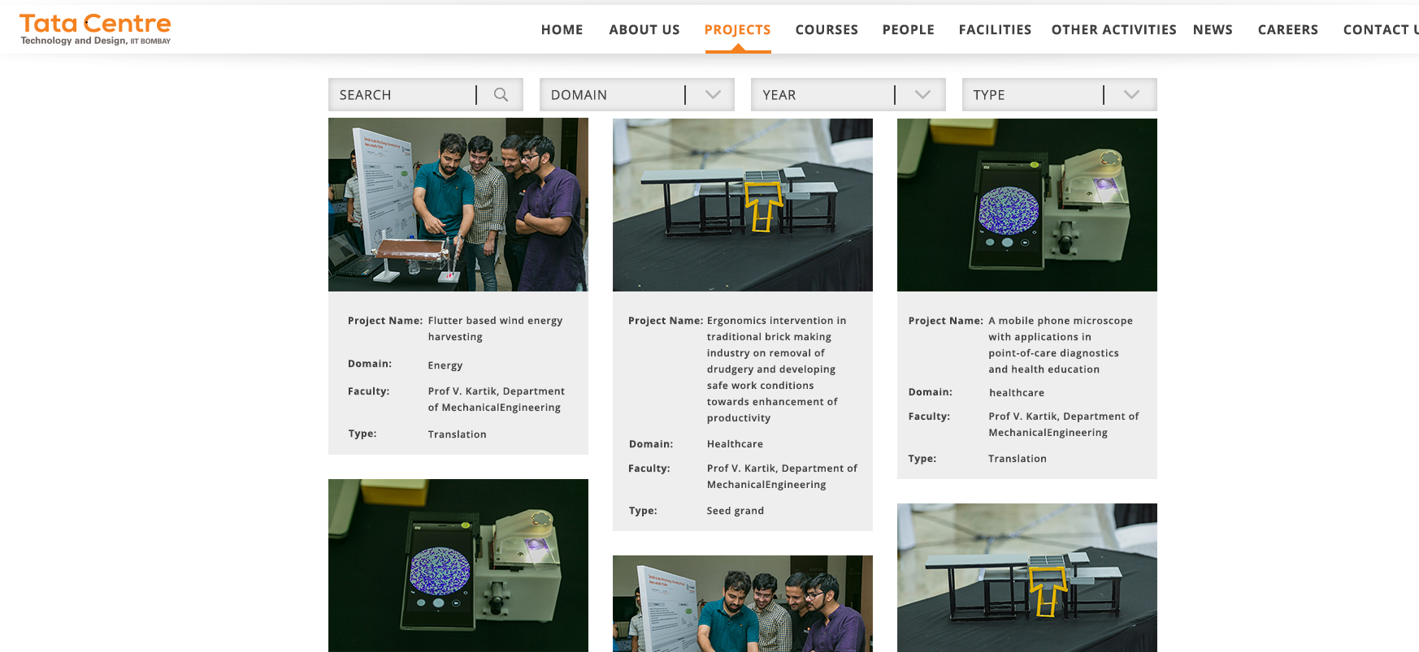

New Project page design (Fig 2)

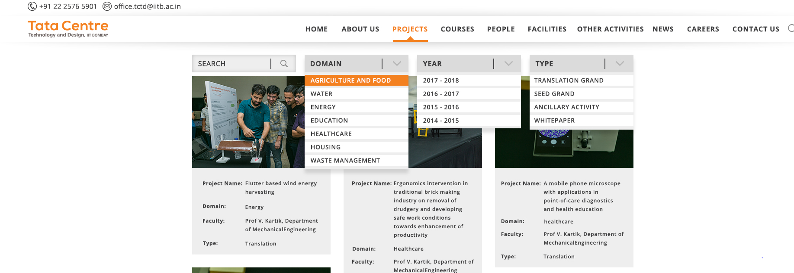

New Project page design (Fig 3)

After selecting particular project, it will navigate to project specified page which will give detailed information about project.

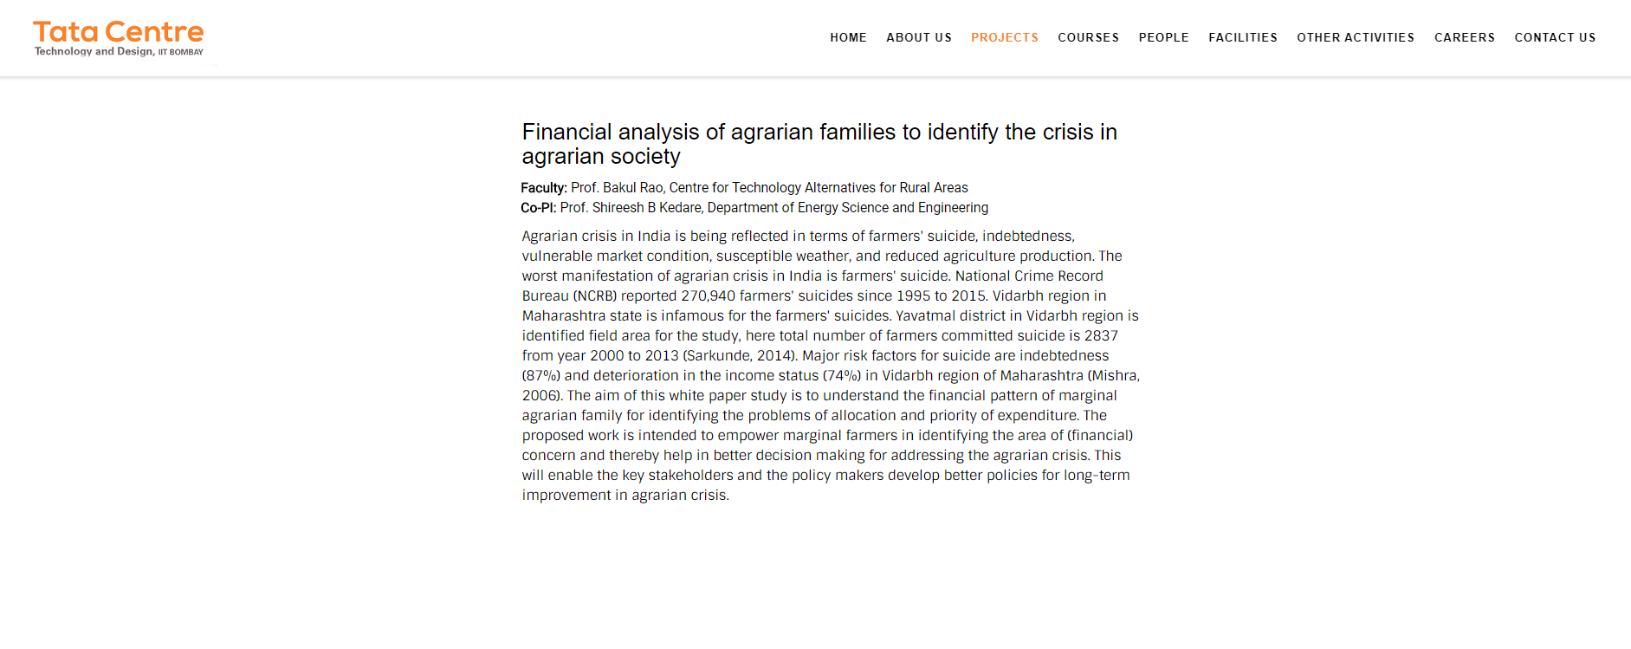

Project Inside page design without Project Image Gallery (Fig 4)

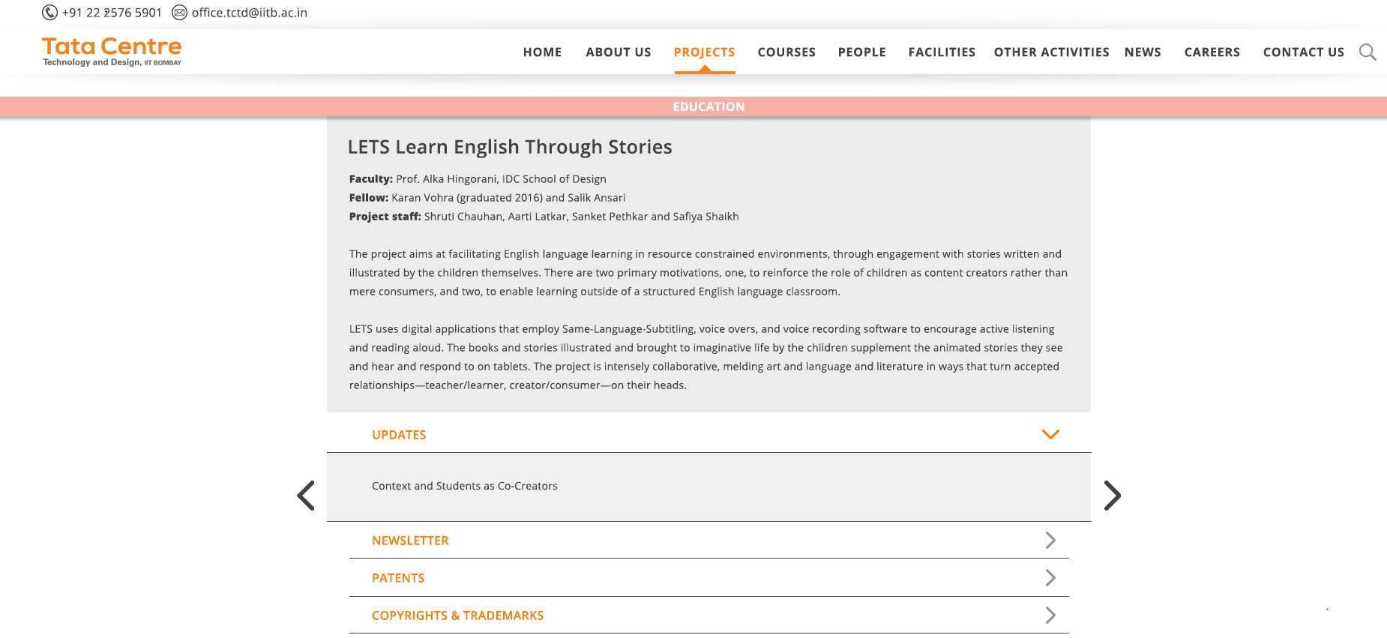

New Project Inside page design without Project Image Gallery (Fig 5)

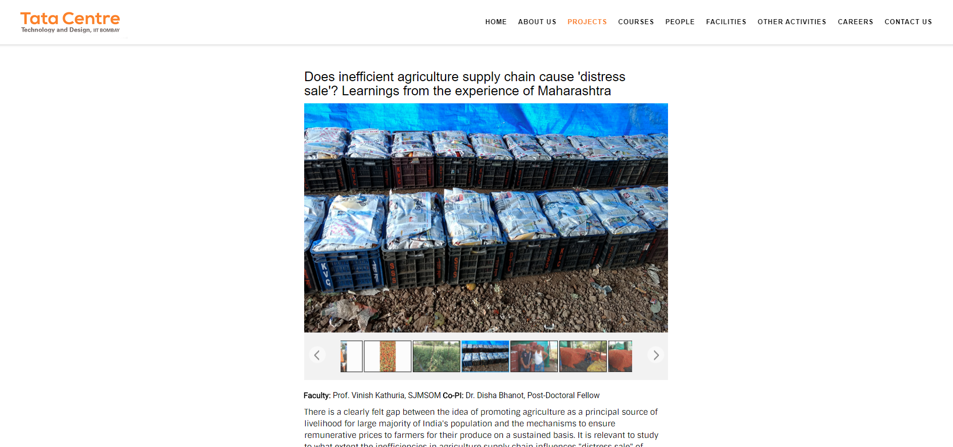

Project Inside page design with Project Image Gallery (Fig 6)

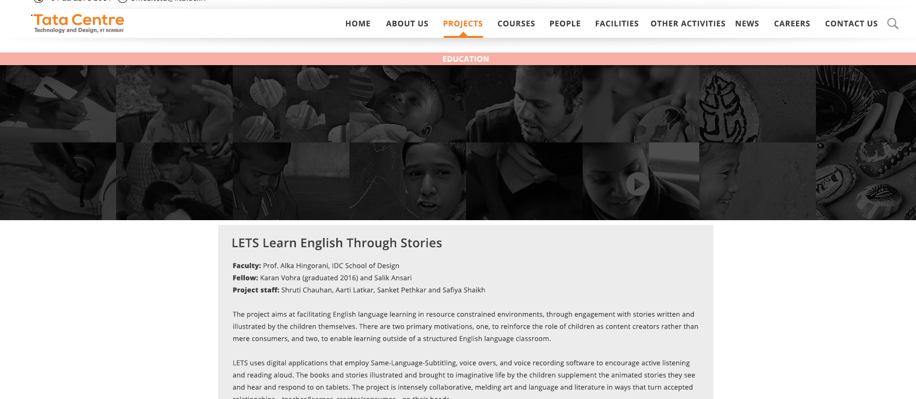

New Project Inside page design with Project Image Gallery (Fig 7)

Interaction between Project and People

There is project Faculty for each project who is owner of that project. CO- Project Investigator, Fellows and Project Staff are project entities who manages project.

For Eg: <http://www.tatacentre.iitb.ac.in/jaggery.php>

People

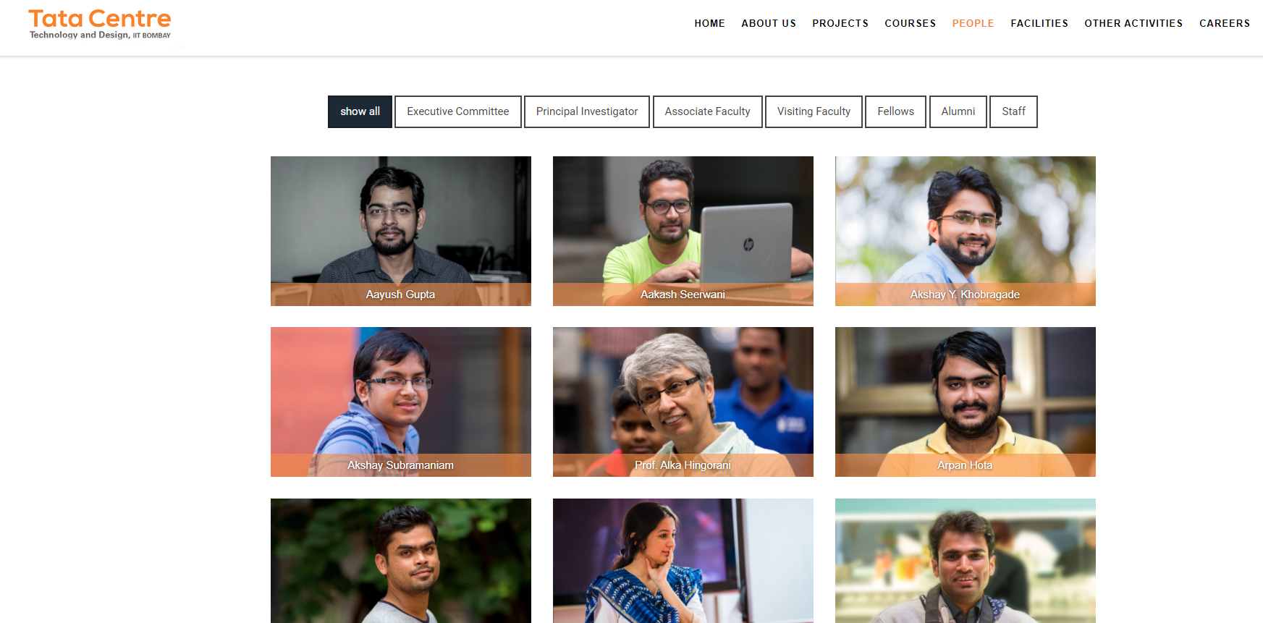People Page Design (Fig 8)

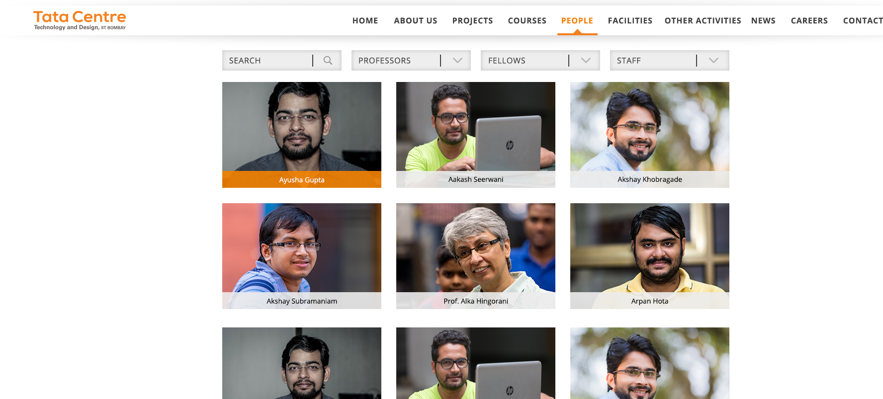

New People Page Design (Fig 9)

After clicking on particular people, it will redirect to people specified page which will give detailed information about staff or other people.

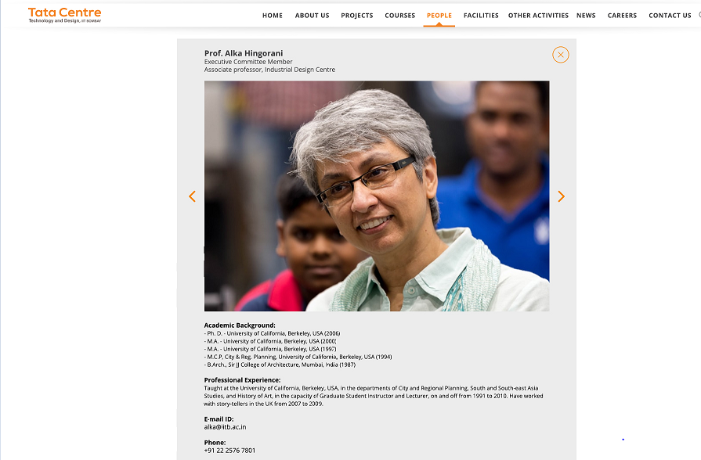

New People Inside Page Design (Fig 9)

Home Page

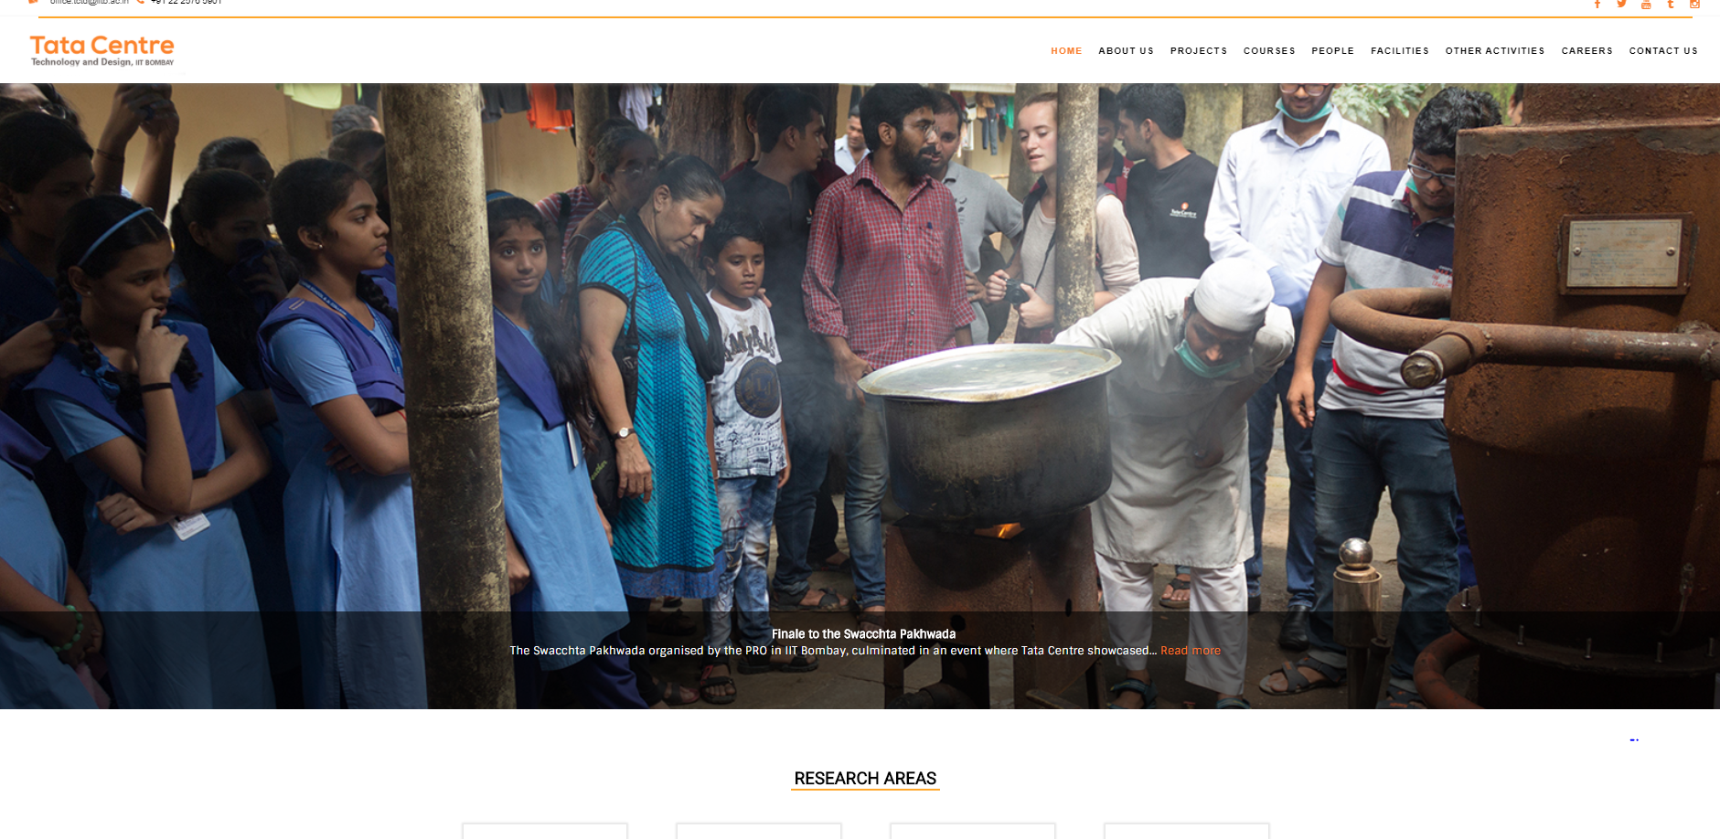

Current Home Page(Fig 10)

<http://www.tatacentre.iitb.ac.in/index.php>

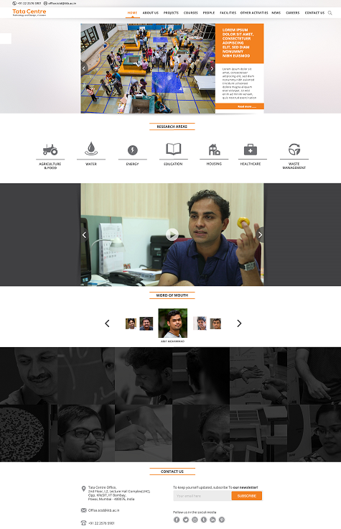

New Home Page Design (Fig 11)